**Facility Mapping**

1

2

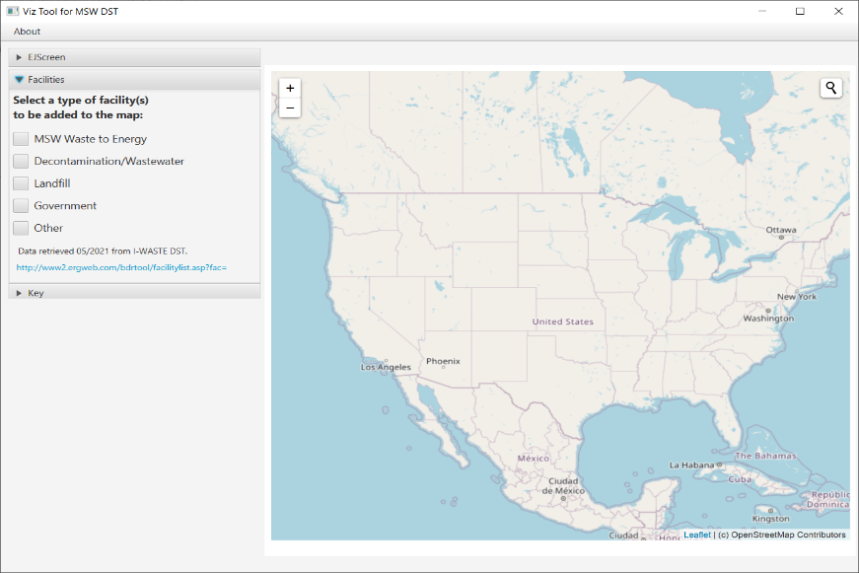

To populate the facilities, follow the directions below.

* 1. Open the accordion panel on the left side of the window labeled “Facilities”.
  2. Select any number of facility types.
  3. The map will now display any facilities that are of the selected type(s).

**EJ Raw Data**

* To retrieve EJ raw data, follow the directions below.

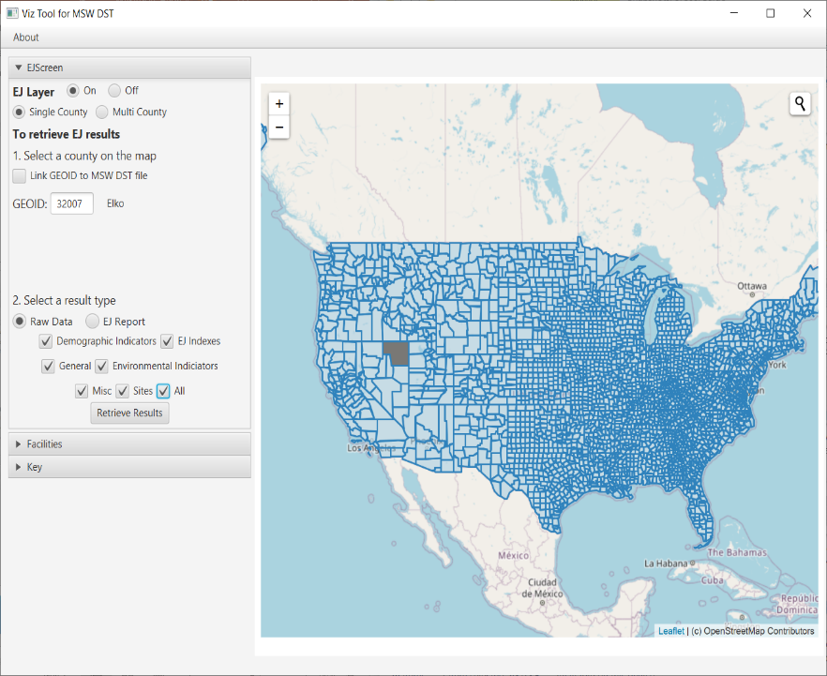

1

2

3

4

5

6

7

* 1. Open the accordion panel on the left side of the window labeled “EJScreen”.
  2. Select the radio button labeled “On” next to the label “EJ Layer”.
  3. Select the radio button labeled “Single County”.
  4. Select any county on the map.
  5. Select the radio button labeled “Raw Data” under “Select a result type”.
  6. Select any of the checkboxes that have populated
  7. Select the button labeled “Retrieve Results”.

**EJ Raw Data Visualization**

* To view the EJ raw data visualizations, follow the directions below.
  1. Open the accordion panel on the left side of the window labeled “EJScreen”.

7

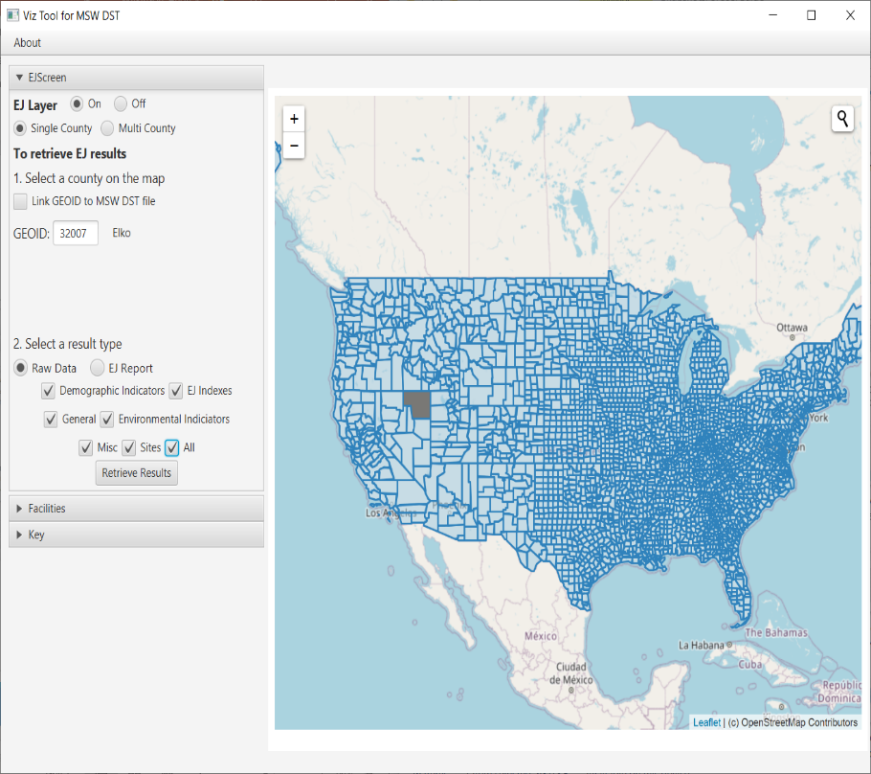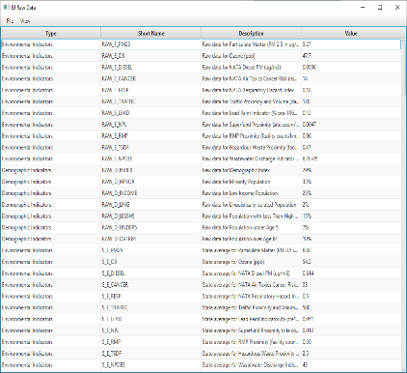

1

2

3

5

4

8

6

* 1. Select the radio button labeled “On” next to the label “EJ Layer”.
  2. Select the radio button labeled “Single County”.
  3. Select any county on the map.
  4. Select the radio button labeled “Raw Data” under “Select a result type”.
  5. Select any of the checkboxes that have populated.
  6. Select the button labeled “Retrieve Results”.
  7. On the “EJ Raw Data” window, select the menu item labeled “View”.
  8. Select the option labeled “Visualize Data”.

**EJ Report Retrieval**

* To view an EJ Report, follow the directions below.
  1. Open the accordion panel on the left side of the window labeled “EJScreen”.

2

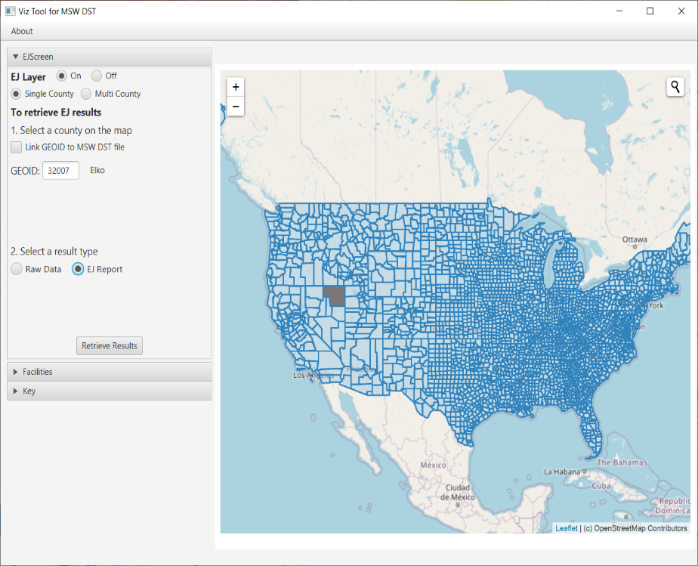

1

3

4

5

6

* 1. Select the radio button labeled “On” next to the label “EJ Layer”.
  2. Select the radio button labeled “Single County”.
  3. Select any county on the map.
  4. Select the radio button labeled “EJ Report” under “Select a result type”.
  5. Select the button labeled “Retrieve Results”.

**MSW DST Data Link**

* To link MSW DST data to a GEOID, follow the directions below.

4

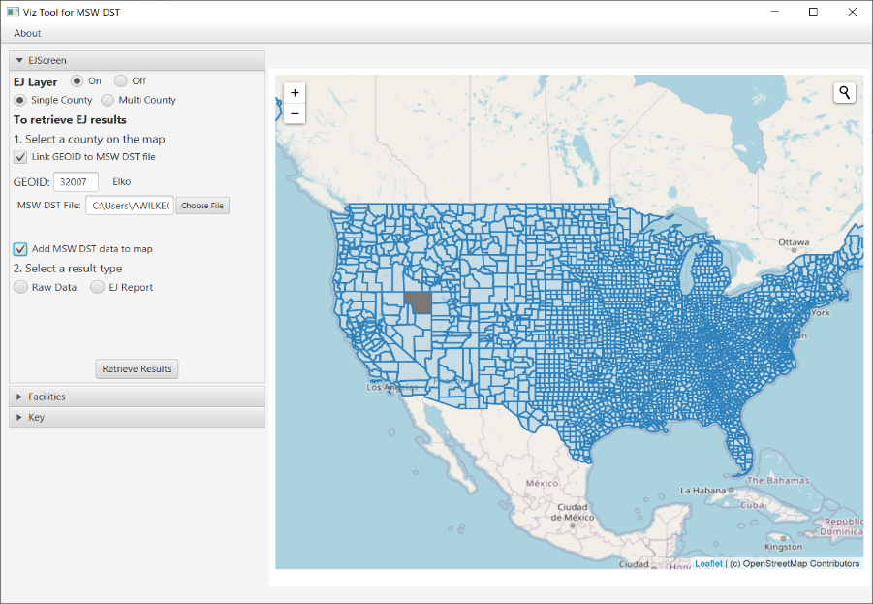

1

2

3

6

5

7

* 1. Open the accordion panel on the left side of the window labeled “EJScreen”.
  2. Select the radio button labeled “On” next to the label “EJ Layer”.
  3. Select the radio button labeled “Single County”.
  4. Select the checkbox labeled “Link GEOID to MSW DST file”.
  5. Select any county on the map.
  6. Select the button labeled “Choose File” and select any MSW DST result file.
  7. Select the checkbox labeled “Add MSW DST data to map”.